Task: 2

Name: Hazem Walid Fawzy

ID: 2200690

Table of Contents
Contents
1.Problem Description: 2
1.1 The 8×8 Problem: 2
1.2 The n×n Problem: 2
1.3 Minimum Moves Objective: 2
2.Solution Explanation 2
2.1 Warnsdorff's Greedy Algorithm 2
2.2 Pseudocode For greedyTour(int n,int startR,int startC) : 3
Degree Function: 4
2.3 Step-by-Step Methodology: 4
2.4 Implementation Code: 5
3. Time and Space Complexity Analysis: 7
3.1 Warnsdorff's Greedy Algorithm: 7
4. Advantage and Disadvantage for the Warnsdorff's Greedy Algorithm: 7
4.1 Advantage: 7
4.2 Disadvantages: 7
5. Comparative Evaluation of Techniques: 8
6. Complete Analysis and Alternative Approaches: 8
6.1 Closed Tour on 8×8: Theoretical Answer: 8
6.2 General n×n: Detailed Case Analysis: 9
6.3 Parity Argument: 9
6.4 More Efficient Alternatives 9
7. Sample Outputs: 10
7.1 Case 1: (n = 1): 10
7.2 Case 2: (n > 5): E.X : n = 3: 10
7.3 Case 3: (Odd Board): E.X : n= 7 : 10
7.4 Case 4: (Even Board) and (Closed tour) : E.X: n=8: 11
7.5 Case 5: Failed Tour: E.X : n=7: 11
7.6 Case 6: Invalid Starting Position:E.X:n=5: 11
8. Key Findings and Insights 12
9. References 12

1.Problem Description:

1.1 The 8×8 Problem:
Given a 8×8 chessboard the task is to determine whether a chess knight can visit every cell exactly once returning to its starting position (closed or re-entrant tour). This is a Hamiltonian cycle problem on the knight's graph—the graph whose vertices are chessboard squares and whose edges connect squares that a knight can reach in one move.

1.2 The n×n Problem:
for which values of n > 8 does a closed knight's tour exist on an n × n board? The answer depends on the parity of n and the starting position chosen:
- For n < 5: No knight's tour of any kind (open or closed) is possible because the board is too small for the knight to reach all squares.
- For n = 5: Open tours exist. Closed tours doesn’t exist .
- For even n ≥ 6:
Both open and closed tours exist for all starting positions.
- For odd n ≥ 7:
Open tours exist, but closed tours are impossible due to parity constraints.

1.3 Minimum Moves Objective:
A complete knight's tour on an n × n board visits all n² squares. Since each move takes the knight to exactly one new square, a complete tour requires exactly n² moves because I have a count(move) start from 1. For the 8×8 board, this is 64 moves. The greedy algorithm (Warnsdorff's rule) aims to find such a tour efficiently.

2.Solution Explanation

2.1 Warnsdorff's Greedy Algorithm
Warnsdorff's rule is a greedy heuristic for the knight's tour problem, proposed by H. C. von Warnsdorff in 1823. The key insight is:
At each step, move the knight to the accessible unvisited square with the fewest onward moves (minimum degree).
This heuristic significantly reduces the search space compared to brute-force methods.
While it does not guarantee finding a tour for every starting position,
it performs efficiently in practice and frequently produces complete tours for board sizes n ≥ 5.

2.2 Pseudocode For greedyTour(int n,int startR,int startC) :

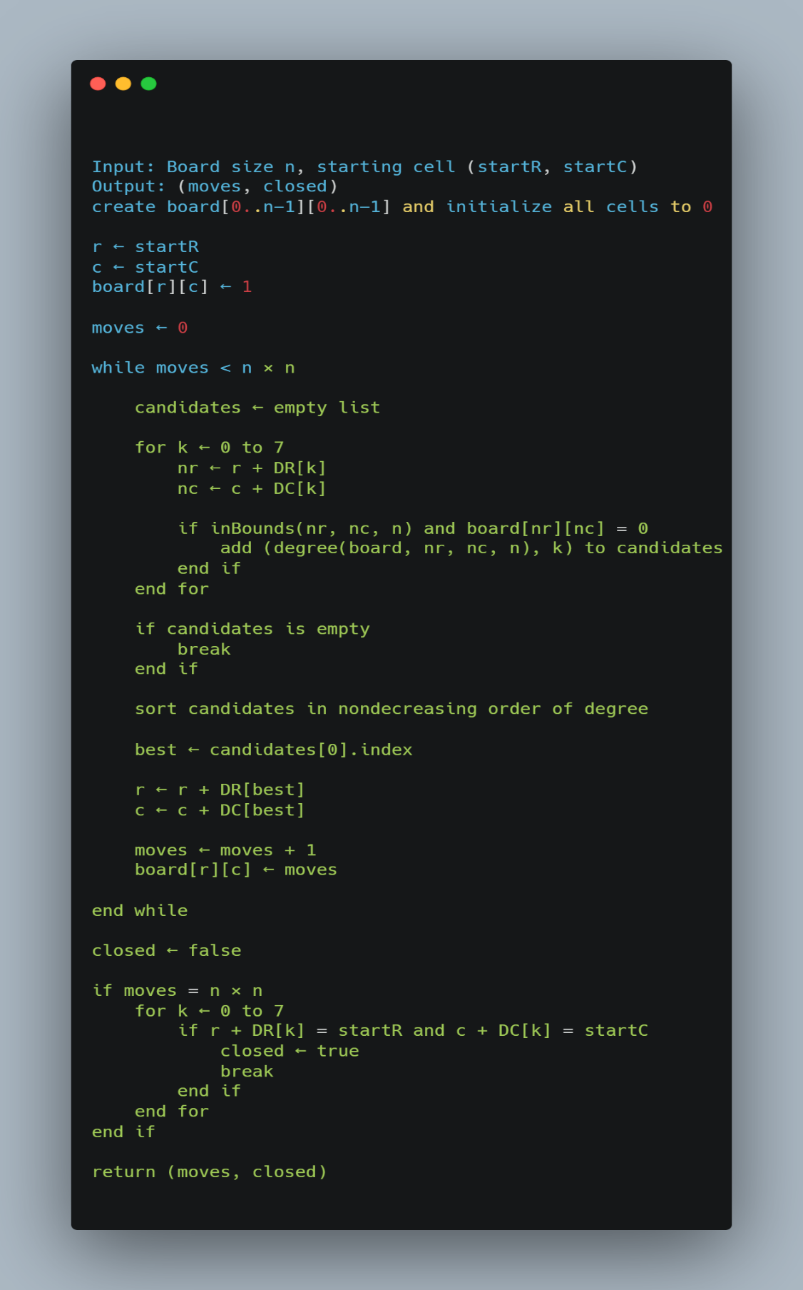

Degree Function:
Function degree(board, r, c, n):
count = 0
For each of 8 knight moves k:
nr = r + DR[k]; nc = c + DC[k]
If inBounds(nr, nc, n) AND board[nr][nc] == 0:
count++
Return count

2.3 Step-by-Step Methodology:
• Read input:
- Board size m
- Starting position (startR, startC)
• Loop over board sizes from 1 to m
• Handle special cases:
- If n = 1 → trivial solution
- If n = 2, 3, 4 → no knight’s tour exists
- If the starting position is outside the board → invalid position
• Initialize the board:
- Create an n × n matrix
- Fill all cells with 0 (unvisited)
• Place the knight at (startR, startC)
• Initialize:
- moves = 1
• Repeat until all cells are visited:
- Generate all 8 possible knight moves
- Filter valid moves:
Inside the board
Not previously visited
- For each valid move:
Compute its degree (number of onward moves)
• Apply Warnsdorff’s rule:
- Select the move with the minimum degree
• Move the knight:
- Update the current position (r, c)
- Increment moves
- Mark the new cell as visited
• If no valid moves are available:
- Stop execution (failure)
• After traversal:
- If moves = n × n → the tour is complete
• Check whether the tour is closed:
- If the last cell is one knight move away from the starting cell → Closed
- Otherwise → Open
• Print the result:
- Number of visited cells
- Complete or Failed
- Open or Closed

2.4 Implementation Code:

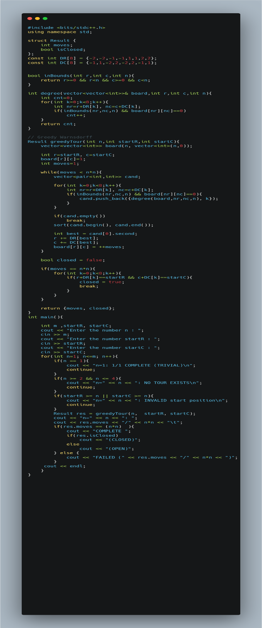

3. Time and Space Complexity Analysis:

3.1 Warnsdorff's Greedy Algorithm:
Time and Space Complexity Analysis
O(n²) | Time Complexity
O(n²) | Space Complexity
The total time complexity of Warnsdorff's algorithm is O(n²).This is because at each of the n² steps, the algorithm examines at most 8 possible moves (a constant), computes the degree of each (again at most 8 checks each = O(1)), sorts the small list (at most 8 elements, O(1)), and makes one deterministic move

4. Advantage and Disadvantage for the Warnsdorff's Greedy Algorithm:

4.1 Advantage:
Fast and efficient
Runs in $O(n^{2})$, significantly faster than brute-force approaches.
Simple to implement
Based on a clear heuristic (Warnsdorff’s rule), making it easy to code.
Low computational overhead
Each step requires only constant-time operations.
Performs well in practice
Often finds complete tours for board sizes $n≥5$.

4.2 Disadvantages:
Not guaranteed to find a solution
it may fail for some starting positions.
Sensitive to tie-breaking
Poor choices when multiple moves have the same degree can lead to failure.
No backtracking mechanism
Once a wrong decision is made, the algorithm cannot recover.
May produce incomplete tours
It can terminate before visiting all squares.

5. Comparative Evaluation of Techniques:

comparative evaluation
Technique | Time Complexity | Guarantees Tour? | Best For
Warnsdorff's (Greedy) | O(n²) | No (heuristic) | Large boards, practical use
Backtracking | O(8^(n²)) | Yes (if exists) | Exact proof for small n
Divide & Conquer | O(n² log n) | Yes (structured) | Even n, provable results

Warnsdorff's greedy algorithm is the most practical approach for the knight's tour problem, offering O(n²) time complexity and reliable empirical performance. While it does not provide a mathematical guarantee of finding a tour from any starting position, it succeeds in nearly all cases for n ≥ 5. Backtracking, while exact, is only feasible for very small boards. For large boards where Warnsdorff's fails, structured divide-and-conquer approaches can be applied by partitioning the board into smaller subsections, each solvable independently

6. Complete Analysis and Alternative Approaches:

6.1 Closed Tour on 8×8: Theoretical Answer:
Yes a closed knight’s tour exists on the 8×8 chessboard. This has been mathematically proven and computationally verified. In fact, there are exactly 26,534,728,821,064 directed closed knight’s tours on a 8×8 board. Our implementation uses Warnsdorff’s heuristic, which is capable of finding a closed tour for some starting positions, although it does not guarantee success in all case.

6.2 General n×n: Detailed Case Analysis:
Detailed Case Analysis
n | Open Tour | Closed Tour | Explanation
1 | Trivial | No | Single square — no moves are possible.
2 | No | No | Knight cannot make any valid move.
3 | No | No | The board is too small for a complete tour.
4 | No | No | Proven impossible by exhaustive search.
5 | Yes | No | Open tours exist, but closed tours are impossible.
>=6 even | Yes | Yes | Both open and closed tours exist.
>=7 odd | Yes | No | Open tours exist, but closed tours are impossible.

6.3 Parity Argument:
Color the board like a standard chessboard using alternating black and white squares. A knight always moves from one color to the opposite color, alternating colors at every move.
For a closed knight’s tour, the path must form a cycle that visits every square exactly once and returns to the starting position. Such a cycle requires an equal number of black and white squares because every move alternates colors.
When n is even, the board contains an equal number of black and white squares, making a closed tour theoretically possible.
When n is odd, the board contains one more square of one color than the other. Since a knight alternates colors on every move, a closed Hamiltonian cycle becomes impossible on odd-sized boards.

6.4 More Efficient Alternatives
- Divide and Conquer :Splits sufficiently large even-sized boards into smaller quadrants, solves each sub-board independently, and then connects the partial tours using carefully constructed junction moves. This method guarantees finding a closed knight’s tour for all even n ≥ 6 in O(n²) time, with a formal correctness proof
- Graph-Theoretic Approach (Hamiltonian Cycle Algorithms): Models the chessboard as a graph where each square represents a vertex and each legal knight move represents an edge. The Knight’s Tour problem is then reduced to finding a Hamiltonian path or Hamiltonian cycle in the graph. Although this approach is theoretically complete, general Hamiltonian cycle algorithms are computationally expensive and are typically much less efficient than Warnsdorff’s heuristic for practical implementations.

7. Sample Outputs:

7.1 Case 1: (n = 1):
startR : 0
startC : 0
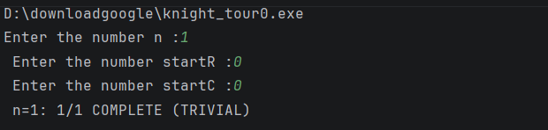
Explanation:
The board contains only one square.
The knight is already on the only cell, so the tour is trivially complete.

7.2 Case 2: (n > 5): E.X : n = 3:
startR : 0
startC : 0
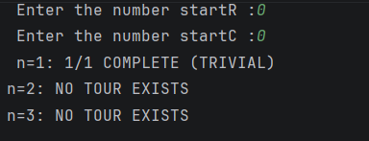
Explanation:
For board sizes 2×2 and 3×3, the knight does not have enough space to visit all cells exactly once.

7.3 Case 3: (Odd Board): E.X : n= 7 :
startR : 0
startC : 0
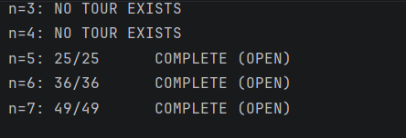
Explanation:
The algorithm successfully visits all 49 squares exactly once.
However, the last square is not one knight move away from the starting square, so the tour is open.

7.4 Case 4: (Even Board) and (Closed tour) : E.X: n=8:
startR : 4
startC : 5
Explanation:
The algorithm successfully visits all 64 squares and finishes one knight move away from the starting position, forming a closed tour.

7.5 Case 5: Failed Tour: E.X : n=7:
startR : 2
startC : 2
Explanation:
The greedy heuristic became trapped before visiting all squares.
This occurs because Warnsdorff’s Rule is heuristic-based and does not guarantee success for all starting positions.

7.6 Case 6: Invalid Starting Position:E.X:n=5:
startR : 7
startC : 7
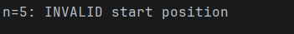
Explanation:
The starting coordinates are outside the board boundaries since valid indices range from 0 to n−1.

8. Key Findings and Insights
- A closed knight's tour is possible on the 8×8 chessboard .
- Not all starting positions on an 8×8 board yield a closed tour; the algorithm must search across multiple starting points when a closed tour is required.
- Closed tours and open tours exist for all even n ≥ 6
- Warnsdorff's heuristic achieves O(n²) time complexity — orders of magnitude better than backtracking's exponential O(8^(n²)) worst case.
- The problem is effectively solved for practical purposes by Warnsdorff's algorithm, which runs instantly even for very large boards .

9. References
- Wikipedia, "Knight's Tour," https://en.wikipedia.org/wiki/Knight%27s_tour
- McKay, B. D., "Knight's Tours on an 8x8 Chessboard," 1997. Available: https://users.cecs.anu.edu.au/~bdm/papers/knights.pdf
- https://www.geeksforgeeks.org/dsa/warnsdorffs-algorithm-knights-tour-problem/
- https://shubham-singh98.medium.com/knights-tour-problem-backtracking-65140571ae44
- https://www.youtube.com/watch?v=FSfeOasUWAc
- TopCoder, "Knight’s Tour Problem,"
https://www.topcoder.com/thrive/articles/knights-tour-problem
- Knight’s Tour Algorithm Explained (Warnsdorff’s Rule): https://www.youtube.com/watch?v=ab_dY3dZFHM

